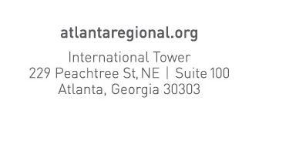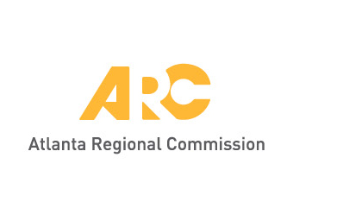

**Date**: August 16, 2018

**To**: Kevin Crump, Director, ARC Center for Business Services

**From**: Mike Alexander, Director, ARC Center for Livable Communities

**Subject**: Alcohol purchases for Regional Leadership Institute

Each year, ARC’s Regional Leadership Institute invites around 50 leaders from the public, private and nonprofit sectors across the 10-county region to participate in a weeklong immersive leadership development experience in Savannah, Ga.

To begin this experience, the class is invited to an orientation reception to get to know each other and to learn more about the program and expectations. This reception is mandatory for class members, as it is crucial that they start the experience together and invest time into RLI. This reception will take place from 5:00-7:00 p.m. on Thursday, September 13, 2018.

The reception will include passed hors d’oeuvres, food stations, and both alcoholic and non-alcoholic beverages. We have found over the years that participants appreciate and enjoy this event, so it has become an essential function of the overall RLI program.

Only private funds (sponsorship funds) are used to pay for these costs, and will be paid by business check. This event will of course take place off-site from ARC’s offices in Atlanta. The location is the Marianna/Wrecking Bar in Inman Park, Atlanta.

Over the years, RLI has provided great value to the region by informing and engaging leaders on issues that are central to Metro Atlanta’s continued growth and competitiveness. Through this year’s program, class members will learn valuable lessons about some of the issues facing our region and form valuable professional connections.

Regards,

Michael D. Alexander, AICP